Computer Architecture Course: IT089IU
International University – VNU HCM Date: March 2019
Dr. Le Hai Duong Time: 4 hours
Laboratory Session 2
Testing and Branching
- MIPS assembler directives
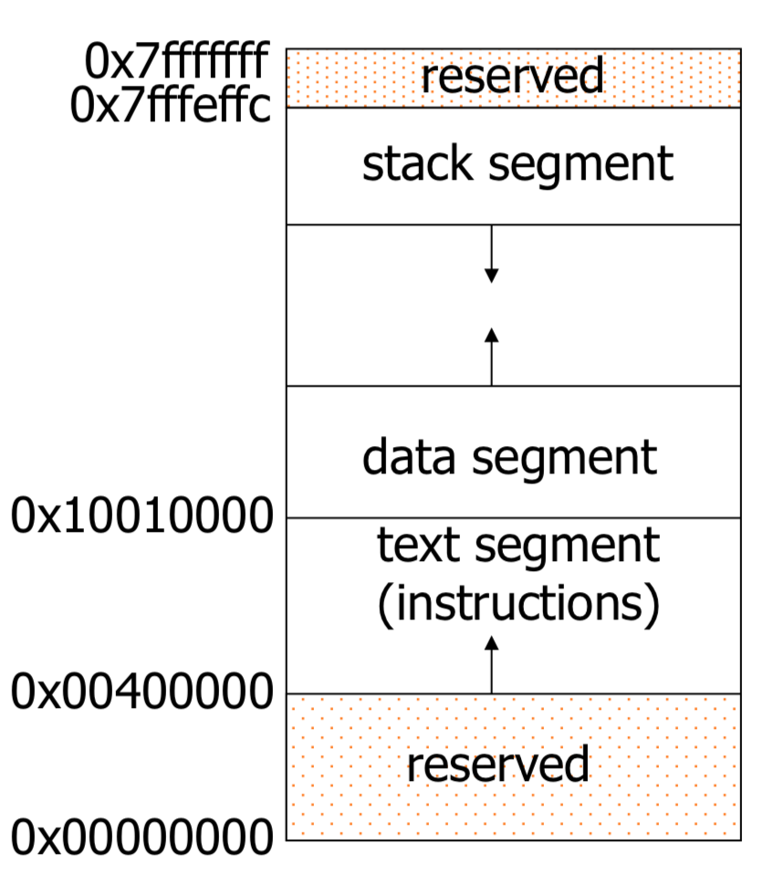
Figure 1 MIPS Memory Usage as viewed in SPIM

.text
indicates that following items are stored in the user text segment, typically instructions
.data
indicates that following data items are stored in the data segment
.globl sym
declare that symbol sym is global and can be referenced from other files

Common data definitions
.word w1, ..., wn
store n 32-bit quantities in successive memory words
.half h1, ..., hn
store n 16-bit quantities in successive memory halfword
.byte b1, ..., bn
store n 8-bit quantities in successive memory bytes
.ascii str
store the string in memory but do not null-terminate it
- strings are represented in double-quotes “str”
- special characters, eg. \n, \t, follow C convention
.asciiz str
store the string in memory and null-terminate it
.float f1, ..., fn
store n floating point single precision numbers in successive memory locations
.double d1, ..., dn
store n floating point double precision numbers in successive memory locations
.space n
reserves n successive bytes of space
.align n
align the next datum on a 2^{n} byte boundary.
For example, .align 2 aligns next value on a word boundary.
.align 0 turns off automatic alignment of .half, .word, etc. till next .data directive

- Pseudo-instructions (30pts)
Pseudo-instructions do not correspond to real MIPS instructions. Assembler would translate pseudo-instructions to real instructions (one or more instructions). Pseudo-instructions not only make it easier to program, it can also add clarity to the program, by making the intention of the programmer clearer.

a)Load the assembly file Lab2_2.s into qtSpim and run. What is the real instruction shown in qtSpim for the pseudoinstruction “li $t0, 5”? ori $8,$0,5
[00400024] 34080005 ori $8, $0, 5 ; 11: li $t0, 5
ori $8,$0,5
ori: or imediate
Before run line 11:
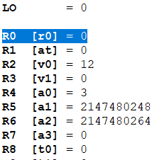
, $0R0 [r0] = 0, R8 [t0]=0
When run line 11
$0: R0 [r0] = 000
with 5 101
result or (R0,5)=101 stored it into $8 [R8]
Result: R8 [t0] = 5
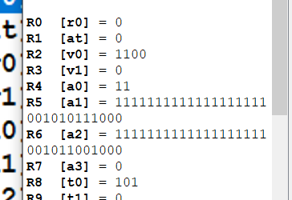
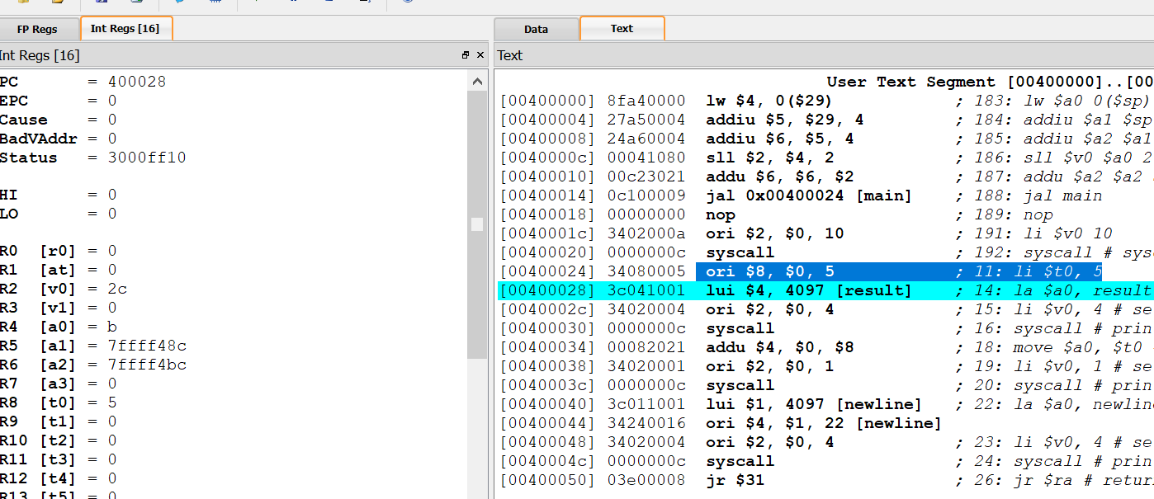

Change the pseudo-instruction “li $t0, 5” in Lab2_2.s to “li $t0, -5”. What are the real MIPS instructions for “li $t0, -5”. Explain how the real instructions work
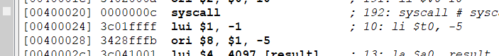
-5 fffffffb_{hex}
The upper of fffffffb is: ffff syntax pseudo-instruction is 3c01ffff lui $1, -1
-1
where $1 is R1 [at] = ffff0000
The lower of fffffffb is : fffb syntax pseudo-instruction is ori $8, $1, -5
$1 is R1 [at] = ffff0000
Or -5 fffffffb
Result: R8 [t0] = fffffffb
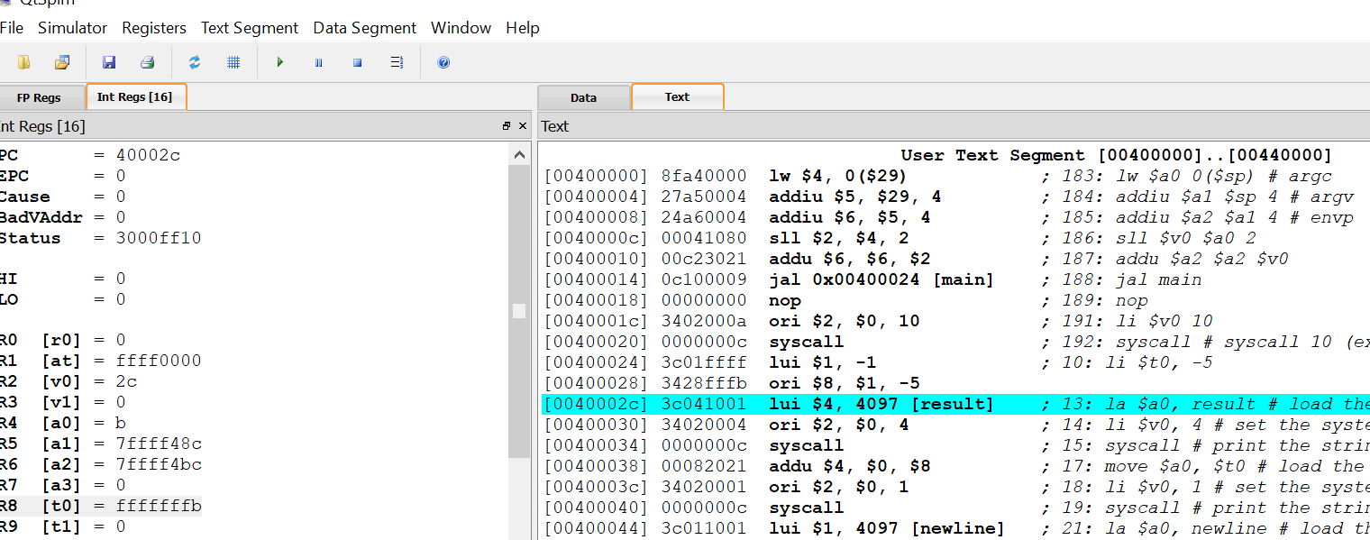
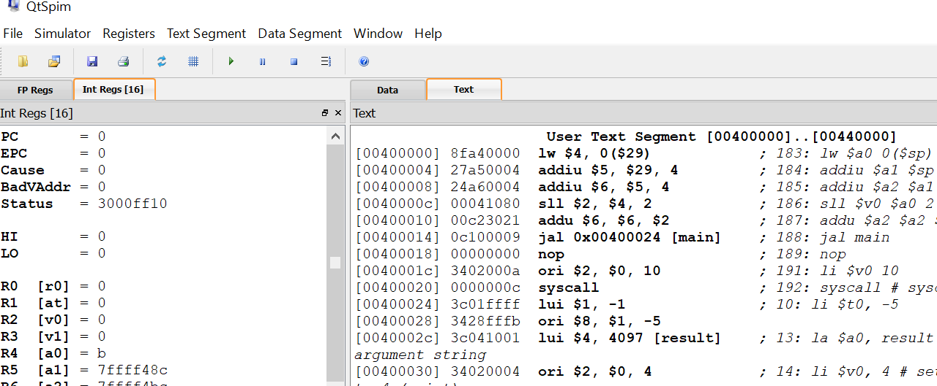
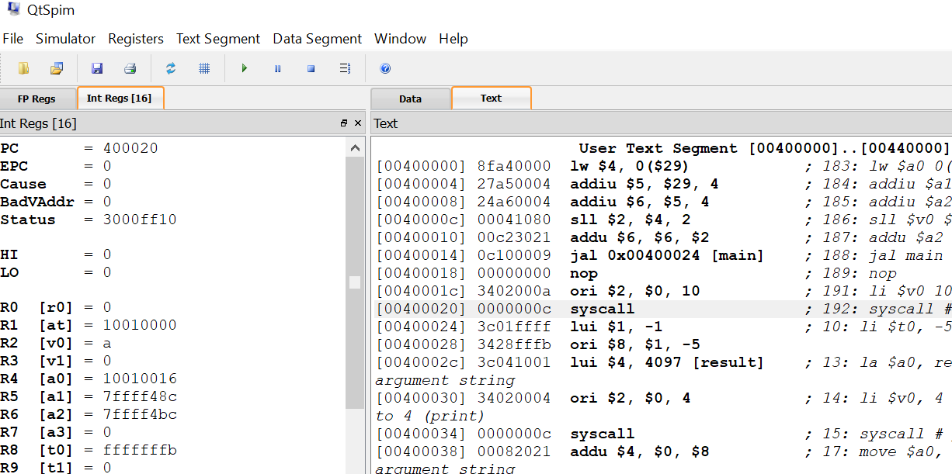
In a 32-bit scheme, the immediate value (-1) is shifted left 16 bits and stored in the register $1, the lower 16 bits are zeroes, then bitwise “or” is performed with the register $1 and thus by smart operation “or”, it stored the immediate value (-5) and stores the result into a register.
lui: load upper immediate, upper = 16 bits
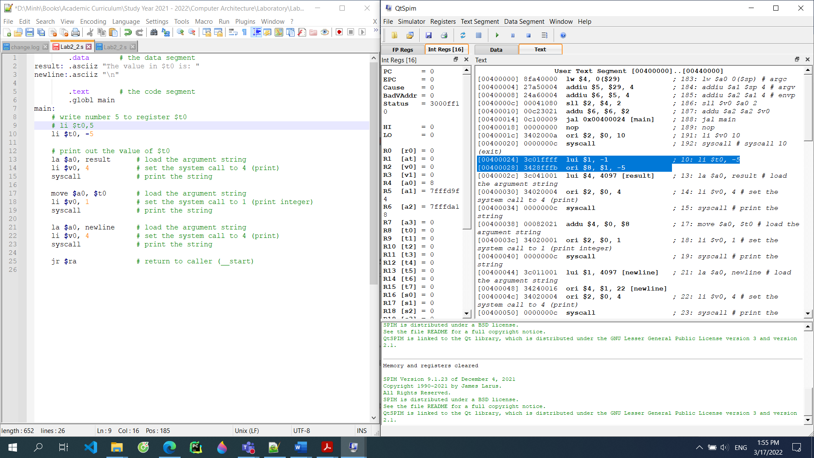

Change the pseudo-instruction “li $t0, 5” in Lab2_2.s to “li $t0, 0xaabbccdd”. What are the real instructions for “li $t0, 0xaabbccdd”. Explain how the real instructions work.
[00400024] 3c01aabb lui $1, -21829 ; 10: li $t0, 0xaabbccdd
[00400028] 3428ccdd ori $8, $1, -13091
-21829 aabb0000 R1 [at] = aabb0000
-13091 - 0000ccdd
result: R8 [t0] = aabbccdd
[00400024] 3c01aabb lui $1, -21829 ; 10: li $t0, 0xaabbccdd
[00400028] 3428ccdd ori $8, $1, -13091
In a 32-bit scheme, the immediate value (-21829) is shifted left 16 bits and stored in the register $1, the lower 16 bits are zeroes, then bitwise “or” is performed with the register $1 and thus by smart operation “or”, it stored the immediate value (-13091) and stores the result into a register.
lui: load upper immediate, upper = 16 bits

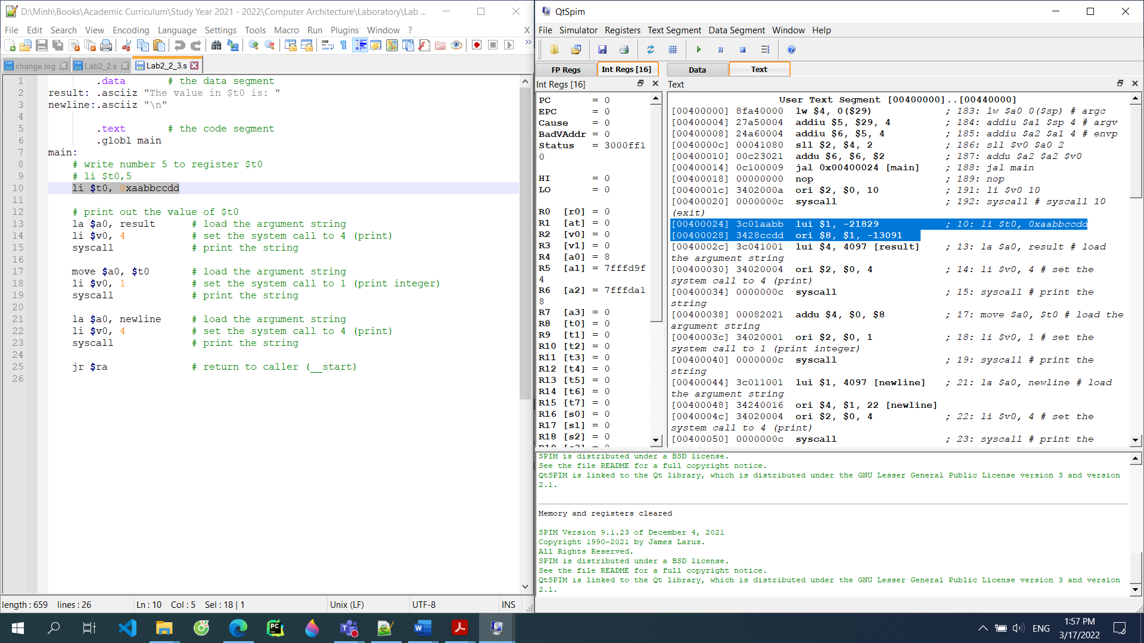

3. Branching (50pts)
Load the assembly file Lab2_3.s into qtSpim and run. Try to win the game. What is the secret number?
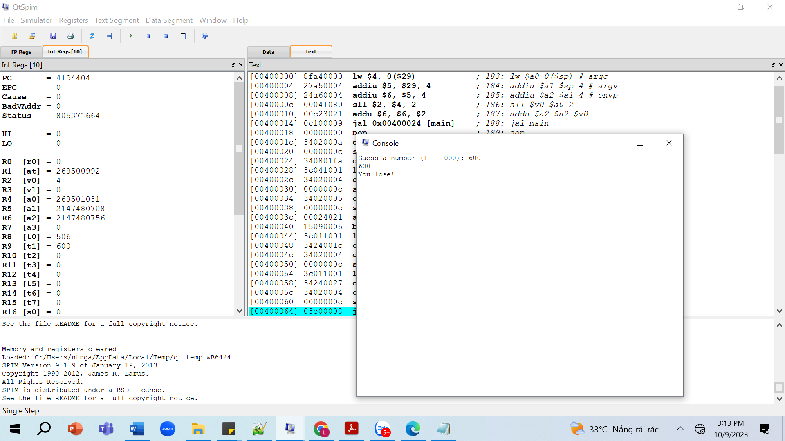
0x1FA in hexadecimal = 506
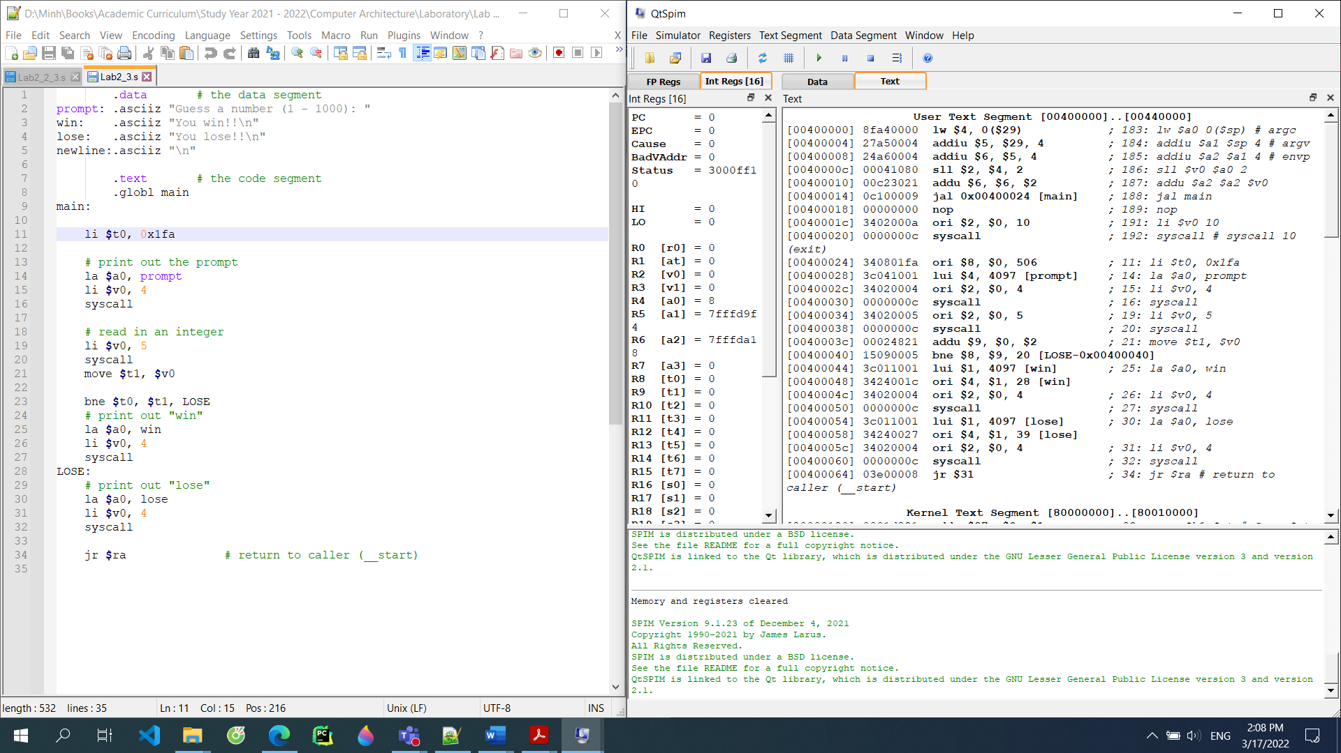
Result (Source Code): Why win and lose in the same time? -> BNE = Branch if NOT EQUAL
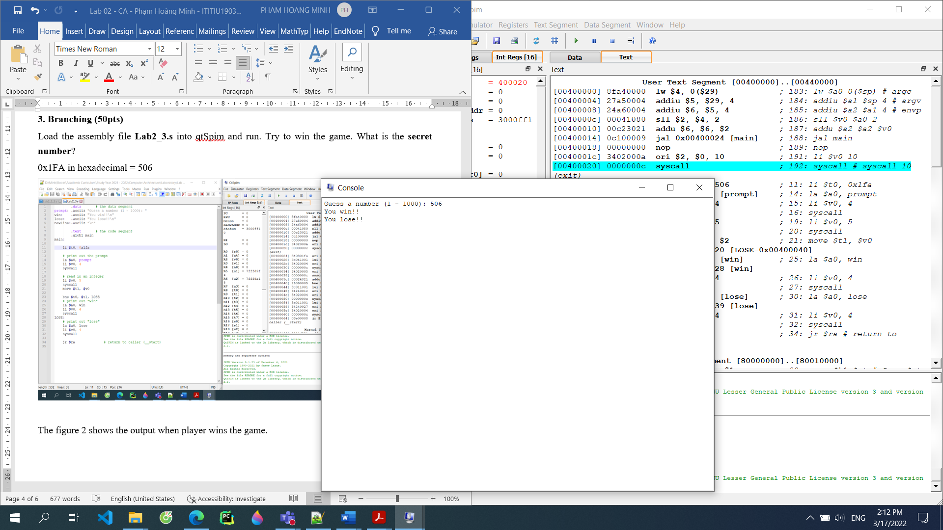

The figure 2 shows the output when player wins the game.
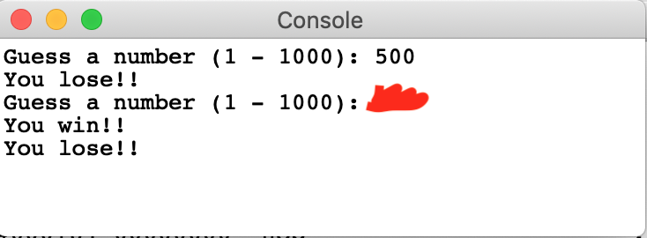

The assembly print both win and lose results. Fix the assembly and save it as Lab2_3.2.s
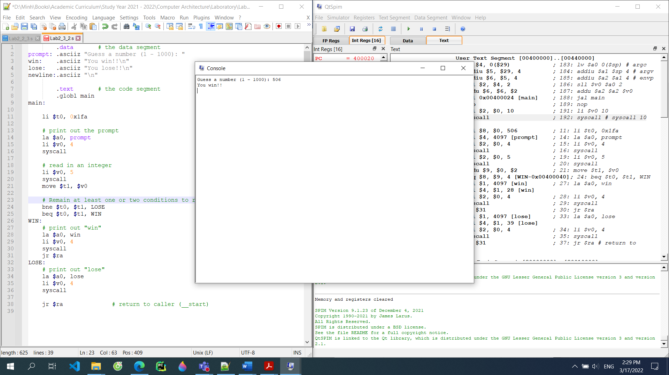

Modify the game so that it will print out as follow (no iteration) using the instructions bgt, or bge, or blt, or ble: Save your file as Lab2_3.3.s

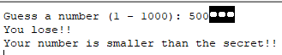

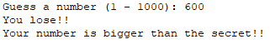

Modify the game so that player can keep guessing until he finds the secret number. Save your assembly as Lab2_3.4.s

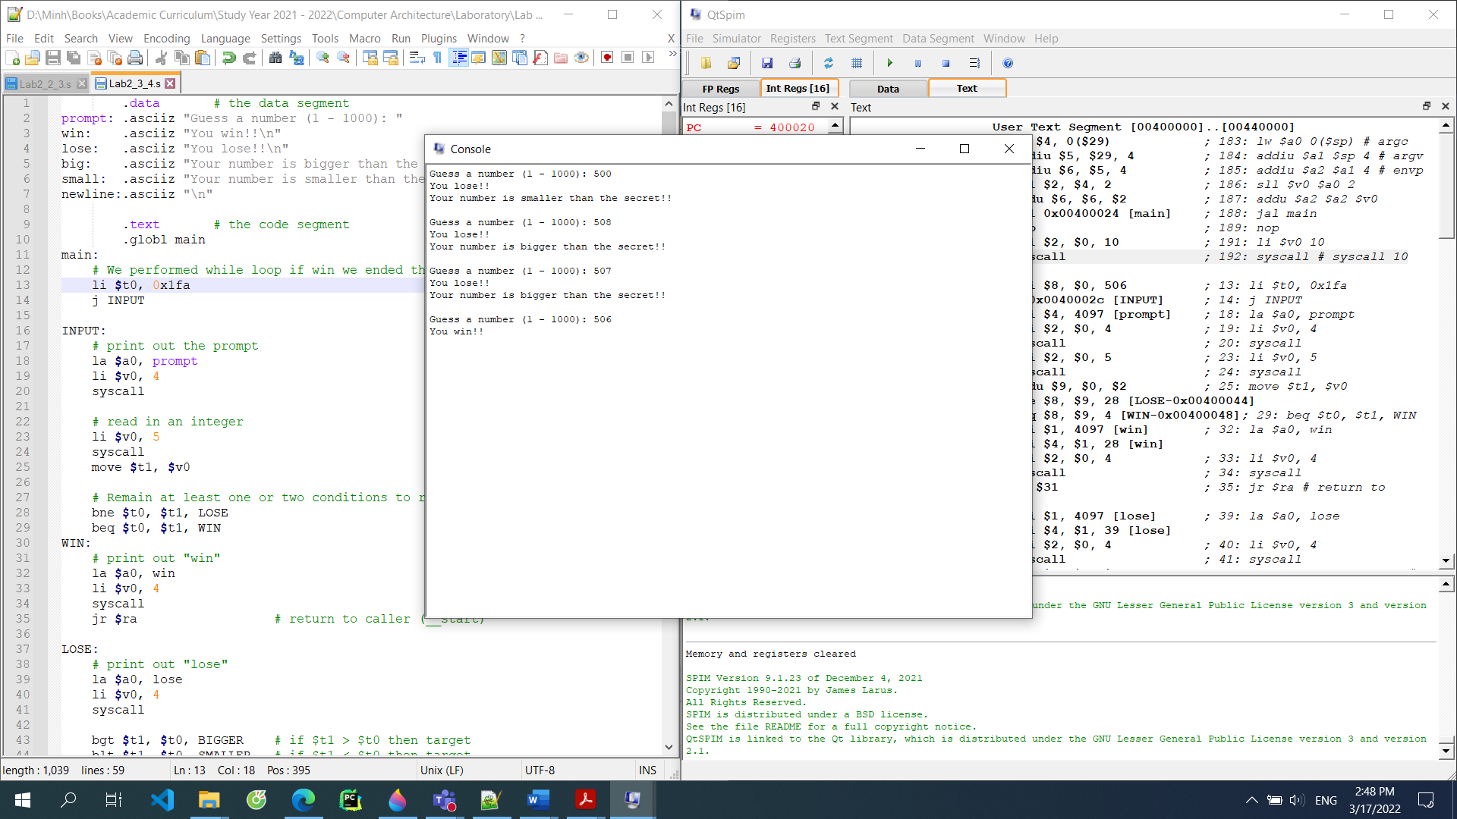

Modify previous version so that player can decide to stop the game by input a flag. Save your assembly as Lab2_3.5.s
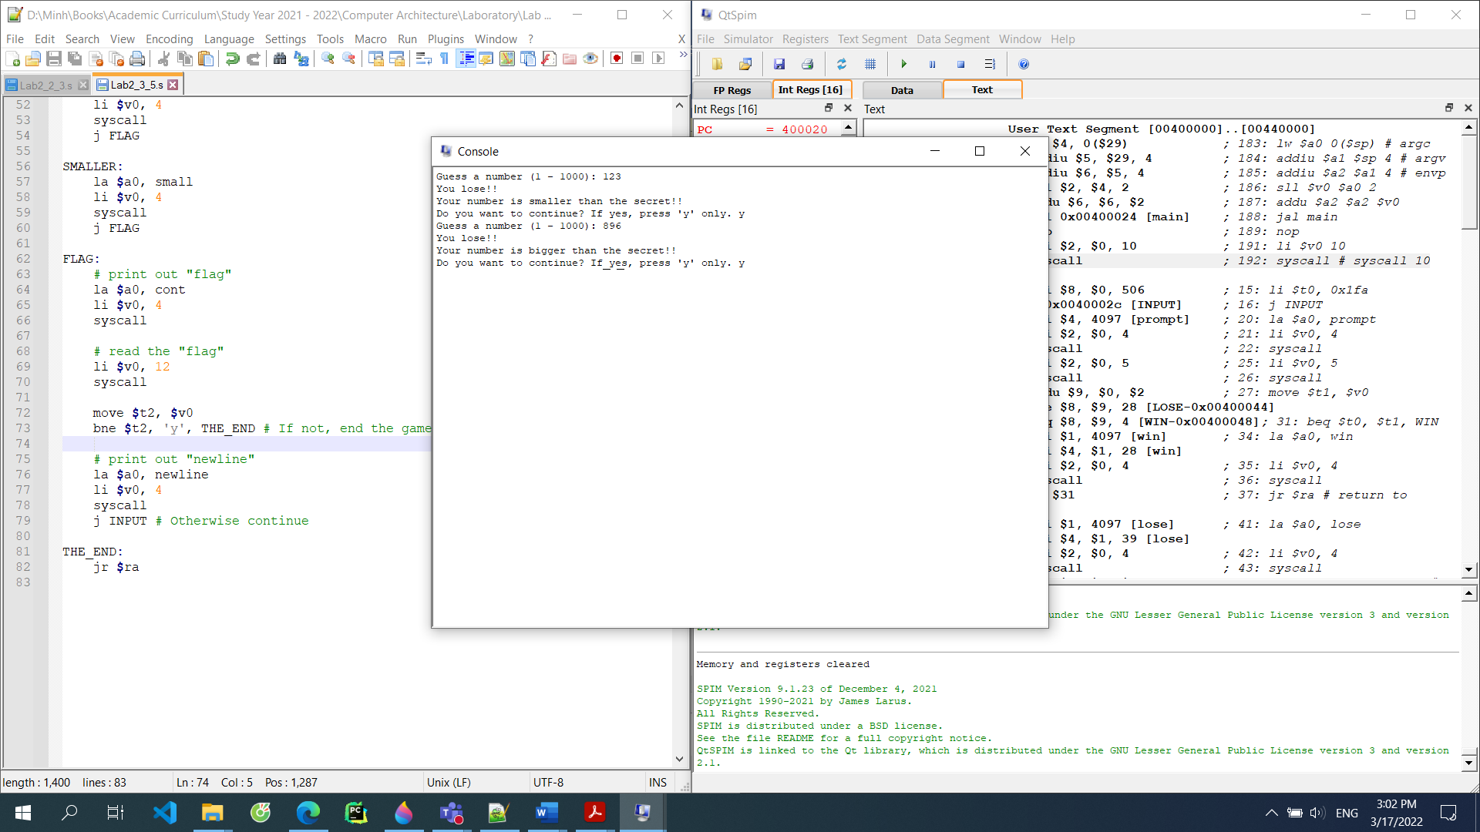

String (20pts)
Write an assembly that convert an input string as follow:
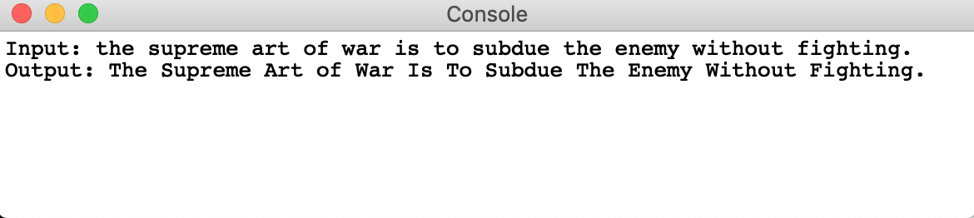

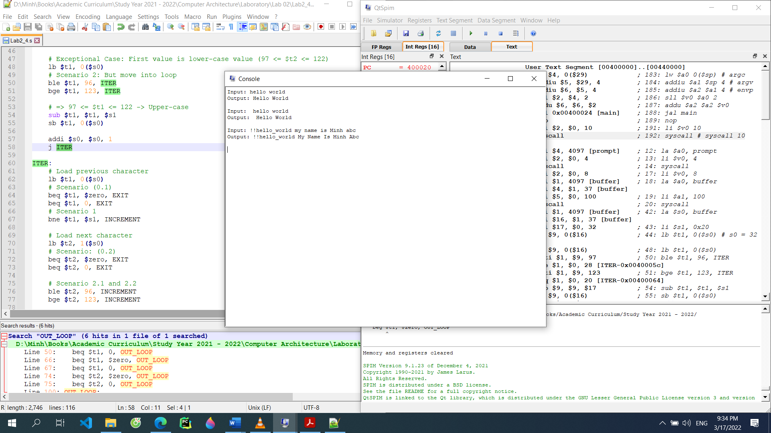

The first letter of every word is capitalized. Save your assembly as Lab2_4.s

5. hidden problem (20pts)

G2_03 (Friday)
Write an assembly that accepts N positive integral numbers from the console window and
verifies whether those numbers are prime.
Save your assembly as Lab2_5.s

G1_01 (Thurs)
Write a MIPS program that tests if a number is a power of two. Set register $t0 to some values in SPIM and use this for testing power of two. The program will generate output in console.
35 is not a power of two.
256 is a power of two.
Save your assembly as Lab2_5.s
Capture your result in here

G2_01 (Monday) -20 points
Write a MIPS program that tests if a number is a fibonacci or not. Input is 0 exit the input number. The output is look like as
Input: 3 4 9 0
Output: 3 is fibonacci
4 is not a fibonacci
9 is not a fibonacci

Save your assembly as Lab2_5.s

G1_02 (Wed)
Write an assembly that accepts N positive integral numbers from the console window and verifies whether those numbers are growing numbers. A growing number contains digits (from left to right) arranged in an increasing order, e.g., 1245, 258, ... At the end, the program prints out each number with the answer.
Save your assembly as Lab2_5.s

Reference:
- https://en.wikibooks.org/wiki/MIPS_Assembly/Pseudoinstructions
- https://courses.missouristate.edu/KenVollmar/MARS/Help/SyscallHelp.html
- https://www.assemblylanguagetuts.com/mips-assembly-programming-tutorials/#MIPS_Data_Types
- https://en.wikibooks.org/wiki/MIPS_Assembly/Arithmetic_Instructions
- https://gab.wallawalla.edu/~curt.nelson/cptr280/lecture/mips%20arithmetic%20instructions.pdf

